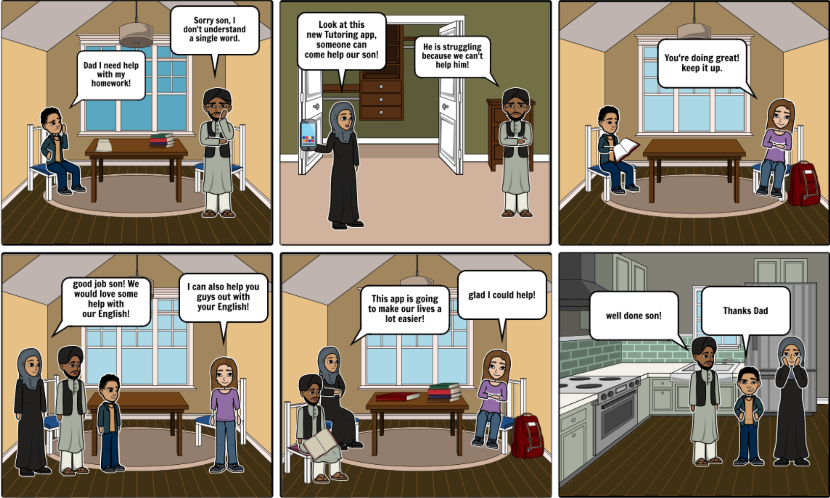Character Storyboard

1. Omar is really struggling with his homework and since his parents know very little English he has no source of help currently.
2. Omar’s mother however has come up with a solution! The release of a tutoring app will allow their son to get help on whatever subject he is struggling with.
3. One of the university students from the application has come over to help Omar with his homework and he is showing great progress.
4. The tutor has now suggested that she can also help the parents with their English!
5. The parents are now studying English with the tutor as well!
6. Everyone is happy and satisfied with what the application had to offer.